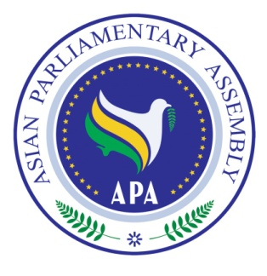

ASIAN PARLIAMENTARY ASSEMBLY
Standing Committee on Staff and Financial Regulations
21-24 May 2017
Abu Dhabi – United Arab Emirates

TENTATIVE PROGRAM OF WORK
DAY ONE
SUNDAY, 21 May 2017
All Day | - Delegates arrive at Abu Dhabi or Dubai International Airport  - Delegates proceed to the Inter Continental Abu Dhabi Hotel  - Registration of Delegates at Inter Continental Abu Dhabi Hotel
DAY TWO
MONDAY,22 May 2017
07:30-08:30 | Breakfast  Venue: Selections
Inaugural Ceremony

Venue: Liwa Majles

- National Anthem of the United Arab Emirates
- Recitation from the Holy Quran
- Welcome remarks by H.E MP Dr. Saeed Al Mutawa, Deputy President of APA – Chair of APA Standing Committee on Staff and Financial Regulations
- Remarks by Honorable Mr. Thavy, Representative of APA President
- Remarks by H.E. Dr. Ali Khorram, APA Deputy
Secretary General
- Opening Address by Honorable H.E Dr. Amal Al Qubaisi, Speaker of the Federal National Council

10:00-10:30 | - Photo Session  - Coffee Break
10:30 - 13:00 | Standing Committee Meeting  Venue: : Liwa Majles Hall, Inter Continental Abu Dhabi Hotel  - Adoption of the Agenda  - Election of the Bureau  - Opening Remarks by the Chairperson  - Report by H.E. Dr. Ali Khorram, Deputy Secretary General of APA  - Reconsideration of Table of Assessed Contribution
13:00- 14:30 | - Lunch Break  - Venue: Selections
16:00 – 19:00 | - Sight-seeing tour of Abu Dhabi
20:00 | - Dinner hosted by H.E. Dr. Amal Al Qubaisi, Speaker of the Federal National Council  - Venue: Al Bateen & Al Baynouna
DAY THREE
Tuesday, 23 May 2017
07:00-08:30 | Breakfast  Venue: Selections
09:00-10:00 | Visit to the Federal National Assembly of UAE
10:00-11:00 | Venue: Liwa Majles  - Consideration of APA Budget for 2018
11:00 - 11:30 | Coffee Break
11:30 - 13:00 | - Consideration and recommendation of Draft Resolution on Planning APA Budget for 2018
13:00 - 14:30 | Lunch Break  Venue: Selections
15:30 – 16:30 | - SCCAP Sub-Regional Groups Meeting  Venue: Executive boardroom C, Meeting quarter 3, Executive boardroom B
DAY FOUR
Wednesday, 24 May 2017
All Day | Departure of Delegates

